Autumn 1  Topic: Stand and Deliver | Autumn 2  Topic: Go with the Flow | Spring 1  Topic The Battle for Britain | Spring 2  Topic: On Top of the World | Summer 1  Topic: What Came First the Chicken or the Egg? | Summer 2  Topic: Light up My Life
Fiction:  Journey to the River Sea Eva Ibbotson (class story)  Non-Fiction:  Collection text extracts relating to crime and punishment– letters  History of Langtoft: Richard Platt  Life of Dick Turpin  Poetry:  The Highwayman:  Alfred Noyes  The Lady of Shalott: Alfred Lord Tennyson | Fiction:  Journey to the River Sea Eva Ibbotson (class story)  Non-Fiction:  Amazing Rivers, Julie Vosburgh Agnone  Protected characteristics guided read  Poetry:  The Brook: Alfred Lord Tenyson  The River’s Story : Brian Patten  https://www.literacyshed.com/the-poetry-shed.html | Fiction:  Goodnight Mr Tom (class story)  Extracts  Michael Morpurgo: Kensuke’s Kingdom,  the Ghost of Grania ~O’Malley,  Why the Whales Came  Non-Fiction:  Selection newspaper articles-  ♦ front pages during WWII/Battle of Britain  ♦ Beast of Bodmin Moor  ♦ Islands of Fire  ♦ News Shed (online)  ♦ Barak Obama’s inaugural speech  ♦ Martin Luther King Jnr. ‘I have a dream speech’  Extracts  ♦ Bill Bryson ‘Notes from a Small Island’  Poetry: WWII poetry  High Flight: John Magee  A Gunner’s Day: Anon | Fiction:  Storm breaker Anthony Horowitz (class story)  Mission Survival: Bear Grylls, Malamander: Thomas Tayor  Non-Fiction:  Great Adventurers: Alistair Humphries,  Extracts:  ♦ Touching the Void: Joe Simpson  ♦ Facing Up: Bear Grylls  ♦ The Death Zone: Matt Dickenson,  ♦ Endurance’s Las  t Voyage : Ernest  Shackleton,  ♦ 20 hrs, 40 min...Our flight in the Friendship: Amelia Earhart  ♦ Everest: Stewart and Stanton  Library books: mountains  Poetry:  extracts Mont Blanc: Shelley  Icarus | Fiction:  Secrets of the Sun King: Emma Carroll (class story)  Non-Fiction:  Great scientists- various extracts  Explanation texts: how the heart works  Biography of Charles Darwin, David Attenborough  Poetry:  Jabberwocky: Lewis Carroll | Fiction:  Secrets of the Sun King: Emma Carroll (class story)  Non-Fiction:  Great scientists- various extracts  History of Langtoft  Poetry:  Funky Chickens: Benjamin Zephania  On the Move: Poems about Migration, Michael Rosen
Reading for Pleasure Recommended choices  (Y6 has the longest list because most children will be off the Reading Scheme) | 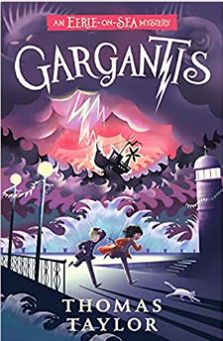  The Shark Caller: Zillah Bethell  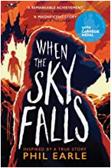  The Middler: Kirsty Applebaum  High Rise Mystery: Sharna Jackson  Survival in Space: David Long  8000 Things you should know: Great Adventures: Alastair Humphreys  Swimming with Sharks: Heather Lang  The Island: Armin Greeder  The Midnight Guardians: Ross Montgomery  Everest: Stewart & Stanton  Darwin’s Dragon:  Malamander: Thomas Taylor  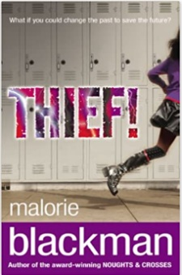  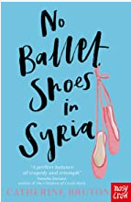  Wildspark:Vashti Hardy  Dread Wood :Jennifer Killick  The Explorer :Katherine Rundell  Oceanarium: Loveday Trinick  Goddess: Females who have shaped belief British Museum  The Invasion of Crooked Oak: Dan Smith  The after School Crime Club:Hayley Webster  A different Sort of Normal: Abigail Balfe  Do You know Me?: Scott and Westcott  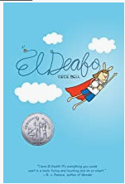  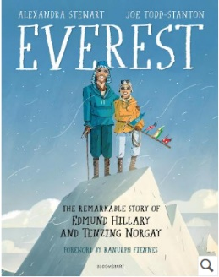  Being Billy: Phil Earle  Boy in the Tower: Polly Ho-Yen  Wonder: R.J.Palacio  Amari: B.B. Alston The Thief Who Sang Storms :Sophie Anderson  First Light: Rebecca Stead A Pocket full of Stars: Aisha Bushby  Crater Lake: Jennifer Killick Bear Grylls: Gold of the Gods  Head Kid: David Baddiel In Darkling Wood: Emma Carroll  Pig Heart Boy: Mallory Blackman Small Steps: Louis Sacher  Swallows and Amazons: Arthur Rasome Secret Water: Arthur Ransome  Goodnight Mr Tom: Michelle Magorian Little Grey Men : BB  The Adventures of Tom Sawyer: Mark Twain Northern Lights Philip Pullman  What not to do if you Turn Invisible: Ross Welford Little Women: Louisa May Alcott  Treasure Island: Robert Louis Stevenson The Girl of Ink and Stars: Kiran Millwood Hargrave  Nation: Terry Pratchett The Harry Potter series: J.K. Rowling  A.N.T.D.O.T.E.: Mallory Blackman The Hobbit: J.R.R Tolkein  The Girl Who Speaks Bear: Sophie Anderson Bear Grylls: Mission Survival

