
Caring ~ Considerate ~ Cooperative ~ Courteous ~ Conscientious ~ Citizenship ~ Courageous
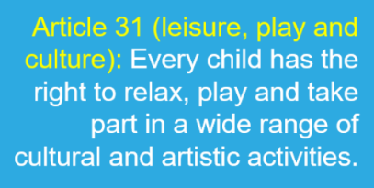
LANGTOFT PRIMARY SCHOOL
Friday Bulletin
13 May 2022

Shout out to year 6!
We have to say a big well done to all of our wonderful Year 6 children for their hard work and determination this week. They have remained level-headed, taking the SATs in their stride and all have tried their best throughout the week, helped along by breakfast club each morning which culminated in bacon and sausage butties today! Thank you to all the adults in Year 6 for supporting the children too.

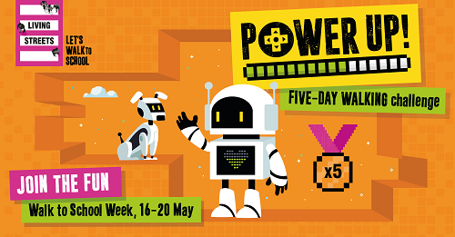
Walk to school week
National Walk to School Week takes place from 16-20 May and we will be encouraging all children to travel sustainably to school every day next week, whether that be by walking, scooting or cycling. Children will be learning about the benefits of walking for individuals, communities and the planet and will be able to earn Dojo points each day, with a special reward up for grabs at the end of the week.
We appreciate some families do need to travel by car but parking further afield and walking some of the way to school would still be of benefit and contribute to helping the environment (plus the traffic around the school).
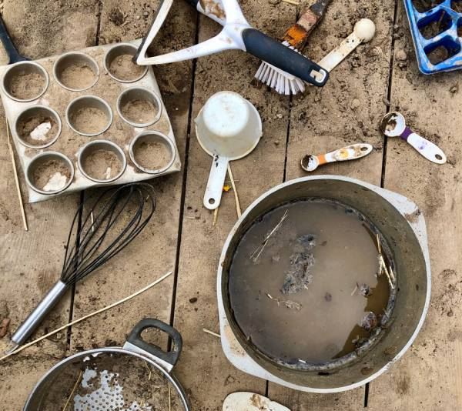
Forest school
We are still collecting pots, pans, kitchen utensils plus patio slabs and bricks for use in our Forest School area as we start to prepare for the launch in September. If you have any of the above items, we would be very grateful for any donations.

Dare to be different day
Remember to purchase your children’s dares for the ‘Dare to be Different’ day on Friday 20 May.
Please select the dare and make payment via the FOLS website by Thursday 19 May.
Writers of the week
This week’s Writers of the Week are Lyla L in Foundation, Grace E in Year 1, Alfie G in Year 2, Oakley C in Year 3, Ella L in Year 4 and Amelia D in Year 5.
The whole of Year 6 have been nominated as superstars this week for their perseverance and hard work during SATs week.

Class updates
For week commencing 16th May 2022
Please find information about what each class are learning next week.

Foundation stage
This week the children will continue to observe and record how their bean is growing as well as taking care of the potatoes and carrots we planted in the outdoor area. They will learn about the artist Andy Goldsworthy and we will create our own nature collages. In maths, the focus is on taking-away as well as recapping counting, number recognition and number bonds. In phonics, the children are working hard to become speedy readers by memorising common words and Fred talking in their head. The children have listened to a variety of fiction and non-fiction texts this term already and they are enjoying their daily vote for which one they would like me to read each morning. We are looking forward to Dare to be different on Friday.

Year 1
Next week in year 1 we will be making an aerial view map of the school in Geography. In Science we are going to be learning about and labelling the structure of a flowering plant. In maths we are going to continue our topic Fractions, where this week we will be thinking about quarters, and in English we are going to be starting a writing journey where we will be discovering the features of fairy tales leading us up to writing our own.

Year 2
Next week Year 2 will be beginning to plan their own chapter of The Owl Who Was Afraid of the Dark. We will look at the features that are in each chapter to help us. We will be completing our reading SATs papers too. In maths, we will be revisiting our number work on addition, subtraction, multiplication and division. We will also be learning how to measure mass. You may want to have a look in your kitchen cupboards to find out how much things weigh. Or you could ask you parents to help you with weighing objects at home. I science we will be finding out about world habitats. We have been enjoying learning how to create sequences in computing using the Scratch Jnr. App. You may want to ask your parents to download it so that you can try it at home too.

Year 3
Next week, we shall be exploring Ancient Egypt in more detail. In English, we will be looking at a variety of areas that may interest the class including mummification, gods, food, building and hieroglyphics. These will then become our main areas of research for our reports that we will eventually write. In maths, we continue with measure, but focus more on perimeter and this is something you could do at home easily. In geography, we shall be looking at settlement types within our surrounding area and creating a simple sketch of this area. In science, we will be exploring how seeds are dispersed and classifying the plants accordingly. We continue with our new class book ‘Varjak Paw’, and feel free to encourage your child to purchase a copy and read along at home too! In PE, we continue with athletics and moving on from jumping to throwing for distance and accuracy. In OAA, we continue to focus on teamwork to achieve a collective goal. Our art this week will be to create our own sculpture based on our foil designs and begin to apply the skills and ideas to a new sculpture.

Year 4
This week in Year 4, we will be focusing on setting descriptions for stories from other cultures. This builds upon the learning we did last week when we were looking at characters. We will be exploring many good examples of setting descriptions so that we are able to identify the features for ourselves. Using this knowledge, we will then look at a bad example and see if we can help to ‘fix it’. In maths, we are going to be concluding our journey on decimals and then learning how we can transfer these skills to working with money.
In science, we will be revisiting classification keys in further detail. We will be able to identify the characteristics of a particular species and learn how to use this information to make detailed classification keys. In music, we will be practising our own version of ‘Blackbird’ and experimenting with improvisation. This week, we will also be continuing to look at the theme of relationships within our PSHE sessions. Our focus this week is thinking about friendships and in particular how to manage disagreements and fall outs.

Year 5
In maths, we subtract two mixed numbers by looking at partitioning the mixed numbers into wholes and parts. Then, we are introduced to multiplying fractions by a whole number for the first time, linking this to repeated addition in order to see that the denominator remains the same, whilst the numerator is multiplied by the integer.
In English, we shall learn about the chocolate making process and begin to write our own explanation text.
In geography, we find information in an atlas using the index & simple co-ordinates and use a key to describe features on an Ordnance Survey map.
In RE, we shall consider how Christians are committed to God and how they show their commitment in different ways. One way is through following the Ten Commandments, which we shall discuss and order according to which ones show most commitment to God.
PE is on Monday (tennis) and Tuesday (rounders).
In music we will be reviewing our Motown unit and singing our core song for the last time with accompanying tambourines!

Year 6
After last week’s SATs, we will get back to business as usual and immerse ourselves in the rest of the curriculum. In English, we will complete our explanation texts, the focus will be on the process of editing and improving punctuation and vocabulary. We then move on to explore and write instructional texts. In maths, we will develop work on pie charts by constructing our own. Later in the week, explore nets for 3d shapes. We will finish and evaluate our mobile phone cases, selecting successful features and areas which could be improved. Athletics and Cricket will carry on in P.E. and we will continue our journey to explore commitment and the concept of what ‘eternal’ means in Christianity.

