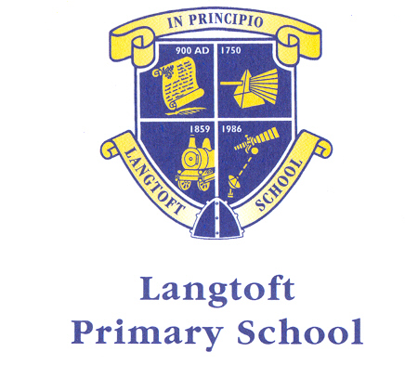
April 2022

Dear Parent/Guardian,
We want to make sure that we are providing your child with the best education and support we can. Healthy school food has obvious health benefits and can help pupils establish healthy habits for life. Healthy school food can also help to improve pupils’ readiness to learn.
Families who receive certain benefits may be eligible for free school meals. Your child is eligible for free school meals if you’re in receipt of one of the following benefits:
- Universal Credit with an annual net earned income of no more than £7,400.
- Income Support
- Income-based Jobseeker’s Allowance
- Income-related Employment and Support Allowance
- Support under Part 6 of the Immigration and Asylum Act 1999
- The guarantee element of Pension Credit
- Working Tax Credit run-on (paid for the four weeks after you stop qualifying for Working Tax Credit)
- Child Tax Credit (with no Working Tax Credit) with an annual income of no more than £16,190

Registering for free meals could also raise an extra £1,320 for your child’s primary school, to fund valuable support like extra tuition, additional teaching staff or after school activities.
This additional money is available from central government for every child whose parent is receiving one of the benefits listed above.
To check if your child is eligible, we need information about you and your child. Please complete the attached form and return to school at your earliest convenience.
Thank you for your support.
Yours sincerely

Mrs B Wood
Headteacher

ABOUT YOUR CHILD/CHILDREN
Child’s Last Name | Child’s First Name | Child’s Date of Birth |  |  | Name of School
 |  | D D | M M | Y Y Y Y
 |  | D D | M M | Y Y Y Y
 |  | D D | M M | Y Y Y Y

PARENT/GUARDIAN DETAILS
 | Parent/Guardian 1 |  |  |  |  |  |  |  |  |  |  |  |  |  |  |  |  |  |  |  | Parent/Guardian 2
Last name
First Name
Date of Birth | D D |  |  |  |  |  | M M |  |  |  |  |  | Y Y Y Y |  |  |  |  |  |  |  | D D |  |  |  |  |  | M M |  |  |  |  |  |  | Y Y Y Y
National Insurance Number*
National Asylum Support Service (NASS) Number* |  |  |  | / |  |  |  |  |  |  | / |  |  |  |  |  |  |  |  |  |  |  |  | / |  |  |  |  |  |  | /
Daytime Telephone Number
Mobile Number
Address | Postcode: |  |  |  |  |  |  |  |  |  |  |  |  |  |  |  |  |  |  |  | Postcode:
Email address

FAMILY INCOME AND BENEFIT DETAILS

If you receive any of the benefits listed below, please place an X in this box.
- Income Support
- Income-based Jobseekers Allowance
- Income-related Employment and Support Allowance
- Support from NASS under part 6 of the Immigration and Asylum Act 1999
- the guarantee element of Pension Credit
- Child Tax Credit (with no Working Tax Credit)
- Working Tax Credit run-on
- Universal Credit.
Universal Credit
If you are in receipt of Universal Credit, is your net earned family income over £7,400 per year? (Please place an X in the appropriate box).
Your net earned income is your household income after taxes and deductions. It does not include income through Universal Credit or other benefits that you may receive.

Yes No Unsure

Child Tax Credit
If you are in receipt of Child Tax Credit, is your joint gross annual income over £16,190 per year? (Please place an X in the appropriate box).
Your joint gross income is your household income before taxes are taken into account.

Yes No Unsure

If you’re not sure whether you receive one of the listed benefits, or what your household income is, but you would still like us to check whether your child is eligible for free school meals, please place an X in this box.

DECLARATION
The information I have given on this form is complete and accurate. I understand that my personal information is held securely and will be used only for local authority purposes. I agree to the local authority using this information to process my application for free school meals. I also agree to notify the local authority in writing of any change in my family’s financial circumstances as set out in this form.

Signature of parent/guardian: ………………………………………………………….
Date:……………………….

Thank you for completing this form and helping to make sure your child’s school is as well funded as possible.
How the information in this form will be used
The information you provide in this form will be used by the council to confirm receipt of one of the listed welfare benefits. Once this is confirmed, this helps to decide how much money your child’s school will receive each year.
All pupils currently receive free meals in reception, year 1 and year 2. However, we would still like you to complete the information so that we can check if your child is eligible for Pupil Premium funding. Also, your child may be eligible to continue to receive free school meals when they are no longer in the infants.
The information will also be used in relation to pupils in year 3 or above to decide whether they are eligible for free school meals.
You only need to complete this form once and it will last for the duration of your child’s time at their current school. You should contact the school or local authority if you have a change in financial circumstances.
We are committed to ensuring that the personal and sensitive information that we hold about you is protected and kept safe and secure, and we have measures in place to prevent the loss, misuse or alteration of your personal information. We will use the information you provide to assess entitlement to free school meals.

